**A**

**PROJECT REPORT**

**ON**

**DROWSY DRIVER DETECTION SYSTEM BY MONITORING EYE MOVEMENTS**

Submitted in partial fulfillment of the requirements for the degree of

Bachelor of Engineering in “**Information Technology**”

Submitted By

**Name of Students**  **ID No**

Apoorva Kambli           VU4F1718069

Ashlesha Deokar VU4F1718071

Vedant Shinde VU4F1718061

Supervisor:

Prof. Prachi Kshirsagar



**Department of Information Technology**

**Padmabhushan Vasantdada Patil Pratishthan's College of Engineering**

Vasantdada Patil Educational Complex, Eastern Express Highway, Near Everard Nagar, Sion-

Chunnabhatti, Mumbai – 400022.

**UNIVERSITY OF MUMBAI**

**May, 2021**

**CERTIFICATE**

This is to certify that the project entitled “**Drowsy Driver Detection System By Monitoring Eye Movements**” is a bonafide work of “Apoorva Kambli” (VU4F1718069), “Ashlesha Deokar” (VU4F1718071), “Vedant Shinde” (VU4F1718061), satisfactorily in the fulfillment of the requirement for the award of the degree of **“Bachelor of Engineering”** in **“Information Technology”** under the guidance of Prof.  Prachi Kshirsagar during the year 2019-2020 as prescribed by Mumbai University.

PROF. PRACHI KSHIRSAGAR

Supervisor/Guide

Dr. SEEMA LADHE Dr. ALAM N. SHAIKH

Head of Department Principal & Campus director

**Project Report Approval for B. E.**

This project report entitled “**DROWSY DRIVER DETECTION SYSTEM BY MONITORING THEIR EYE MOVEMENTS**” by “Apoorva Kambli (VU4F1718069), Ashlesha Deokar (VU4F1718071), Vedant Shinde (VU4F1718061)” is approved for the degree of “**Bachelor of Engineering**” in “**Information Technology**”.

Examiners

1. --------------------------------------

2. --------------------------------------

Date:

Place: Mumbai - 22

# **Declaration**

##### I declare that this written submission represents my ideas in my own words and where others' ideas or words have been included, I have adequately cited and referenced the original sources. I also declare that I have adhered to all principles of academic honesty and integrity and have not misrepresented or fabricated or falsified any idea/data/fact/source in my submission. I understand that any violation of the above will be cause for disciplinary action by the Institute and can also evoke penal action from the sources which have thus not been properly cited or from whom proper permission has not been taken when needed.

-----------------------------------------

(Signature)

Date:

**ACKNOWLEDGEMENT**

We the students from **Padmabhushan Vasantdada Patil Pratishthan’s** College of engineering, Mumbai of **Final Year Engineering** in the department of **‘Information Technology’** have great pleasure in presenting our efforts of developing the project named as **“Drowsy Driver Detection System By Monitoring Their Eye Movements”.**

The success of our project on whole does not depend on an individual student but on the creative team work of entire group & faculty members. This would have difficult by an individual. So we wish & acknowledge the precious guidance from those who willingly supported to us to make this project.

We are grateful to **Dr. Seema Ladhe HOD (IT)** for giving us inspiration, timely guidance and valuable suggestions during the course of project. We are especially thankful to **Prof. Prachi Kshirsagar** for guiding us throughout project work.

(Lastly, we express our sincere thanks to our entire staff of the Information Technology Department for guiding us through the entire course.)

**ABSTRACT**

Living in today's competitive world is getting hectic and in order to keep up with the workload schedule there arises a need to compromise with napping time, due to which people are unable to take rest which indirectly contributes to increased fatigue level.

There is much evidence recorded and studied that at least 1/3rd of the road accidents are related to fatigue. While this fatigue is seen as the driver dozing off unknowingly and losing control of the direction and steering which give rise to hazardous situations.

This project aims to detect the driver's fatigue in real time by monitoring his eye movements and throw an alert if any kind of drowsiness is detected. Our system is developed in such a way that it uses a camera for scanning the facial landmarks of the driver and detect whether the eyes are closed or open which determines the attention span of the driver in the crucial moment of driving. This technology can work on any automobiles hence providing the user a budget efficient technology.

The main reason for motor vehicle accidents is the driver’s drowsiness. This work shows a surveillance system developed to detect and alert the vehicle driver about the presence of drowsiness for the detection of drowsiness, the most relevant visual indicators that reflect the driver's condition are the behaviour of the eyes, the lateral and frontal assent of the head and the yawn. The system works adequately under natural lighting conditions and no matter the use of driver accessories like glasses, hearing aids or a cap. Due to a large number of traffic accidents when a driver has fallen asleep this proposal was developed in order to prevent them by providing a non-invasive system, easy to use and without the necessity of purchasing specialized devices.

It is very dangerous to drive while being tired or after not sleeping for long hours. It is estimated that drowsy driving caused approximately 70,000 crashes, 50,000 injuries, and around 1000 deaths. Moreover, around 6,000 fatal crashes happen every year. A survey revealed that 60% of people have driven a vehicle while feeling drowsy and 37% people admitted that they have fallen asleep while driving in the past one year. 4% drivers admitted they were involved in an accident because they had fallen asleep. Today a large number of these accidents are not recognized because the driver does not inform them that he had fallen asleep as it would make them responsible for the accident and in worst cases it may also lead to loss of life.

Submitted by:

**Name of Students ID No.**

Apoorva Kambli           VU4F1718069

Ashlesha Deokar VU4F1718071

Vedant Shinde VU4F1718061

**CONTENTS**

**ABSTRACT**………………………………………………………….……….……….6

1. **INTRODUCTION**……………………………………………….……….……….8
   1. Introduction………………………………………………….………..………..8
   2. Aim and Objective of project…………………………………………………..8
      1. Aim ……………………………………………………………………9
      2. Objective…………………………………………………………….…9
2. **PROJECT ANALYSIS**……………………………………….………………….10
   1. Literature Survey………………………………………………………………10
   2. Existing system………………………………………………………………...11
   3. Process Of Implementation …………………………………………………...12
   4. Proposed System……………………………………………………………….12
      1. Eye Aspect Ratio……………………………………….………………13
      2. CNN Model ……………………………………………………………15
   5. Algorithms ……………………………………………………………………18
      1. Haar Cascade Algorithm ………………………………………………18
      2. Convolution Neural Network …………………………………………19
3. **SYSTEM REQUIREMENTS** ……….………………………………………… 20
   1. Hardware Specification …………………….………………………………20
   2. Software Specification ……………………….………………………………20
4. **PROJECT IMPLEMENTATION**……………………….………………………21
   1. Use Case Diagram ……………………………………………………………21
   2. Data Flow Diagram ……………………………………………………………22
   3. Eye Aspect Ratio Code…………………………………………………………23
   4. CNN Model Code………………………………………………………………25
5. **RESULT** …………………………………………………...……………………...28
6. **CONCLUSION**……………………………………………………………………30
   1. Conclusion…………………………………………………………………… 30
   2. Future Scope……………………………………………………………………30

**REFERENCES** ……………………………………………………………………….31

**PUBLICATION** ………………………………………………………………………32

**Chapter 1**

**INTRODUCTION**

* 1. **Introduction**

Sleeping is one of the basic needs of the human being, sleep lack causes the body to react inefficiently, reducing both reaction time and wakefulness, also producing low alertness and loss of concentration which reduces the ability to perform activities based on care that is necessary in the case of driving a car. According to many researchers' drowsiness is related to thousands of traffic accidents each year, the accidents produce approximately 50% of death or serious injuries, as they tend to be impacts at high speed because the driver who has fallen asleep cannot brake or deviate to avoid or reduce impact.

It is important to track drowsiness and alert the driver at the same time to prevent such fatal accidents and loss of life. It can also help to spread awareness amongst drivers about the associated risks, improving their driving habits. Such systems are present only in high end cars which are very expensive. They include an automatic braking system when close to another vehicle which is detected by radars, ultrasonic sensors, automatic steering control when experiencing a lot of car drifts on straight roads. However, a very small number of cars comprise these features and it will take a lot of time for these features to become available in many cars built in. While on the other hand our system is cheap, efficient and can be easily used by many people.

Hence in order to cope up with next day’s work they tend to drive after a sleepless night which is very dangerous. It not only places their life under danger but also of the people nearby them and who are dependent on them.

* 1. **Aim and Objective of project**
     1. **Aim**

The aim of this work was to implement a surveillance system to the vehicular driver based on camera vision techniques and implemented in a smartphone in order to detect and alert when the driver has drowsiness signs.

To achieve this aim, other works related with detecting drowsiness in drivers, the drowsiness symptoms in vehicle drivers were analysed. In this work we present a developed drowsiness detection, the interface in which the state of drowsiness is displayed and then works accordingly to get the correct functioning of the system.

* + 1. **Objective**
* Driver drowsiness detection is a car safety technology which helps to save the life of the driver by preventing accidents when the driver is getting drowsy.
* The main objective is to first design a system to detect driver’s drowsiness by continuously monitoring the retina of the eye.
* The system works in spite of drivers wearing spectacles and in various lighting conditions.  To alert the driver on the detection of drowsiness by using a buzzer or alarm.
* Speed of the vehicle can be reduced.
* Traffic management can be maintained by reducing the accidents.

**Chapter 2**

**PROJECT ANALYSIS**

* 1. **Literature Survey**

Drowsiness Detection Systems are a significantly well-known area of research and numerous systems are developed which have shown remarkable results. There are many car models which have developed built-in models which would help to increase security of life and prevent damage of assets.

Bhowmick et al. [2] proposes to identify the individual’s eye states with the help of infrared cameras to detect drowsiness.

Researcher Federico Guede-Fernández of [3] the same field carried on drowsiness detection using respiratory signals. They used the method which uses a real time algorithm for drowsiness detection by Thoracic Effort Derived Drowsiness index (TEDD). The respiratory signal is acquired with an inductive band around the driver’s chest while driving, which will analyse movements, coughing and speaking. They also used an algorithm based on the analysis of the respiratory rate variability (RRV) in order to detect incoming sleep or drowsiness.

There has also been research done by Md Yousuf Hossain [4] where they proposed a system which makes use of IOT technologies like Pi camera needed to capture the images of the driver’s eye and the entire system is incorporated using Raspberry-Pi.

There is another researcher A. Subbarao [5] In their project a spectacle with eye blink sensor is used to detect the driver drowsiness and alerts the driver with a buzzer, if the driver is affected by drowsiness. They have also used various hardware components for this project which are mentioned as LPC2148 microcontroller, Eyeblink sensor, LCD and buzzer.

Sanya Gupta [6] proposed a system in which the software simulation is done through a MATLAB code to implement image processing methods for edge detection and determining the complexity value for the image. The hardware used in the system consists of FPGA Development Board, Camera, Vibration Motors and Speaker.

* 1. **Existing System**

Talking about the existing system, the face detection was done through external cameras, Arduino, glasses, etc. There are a number of ways this functionality has been achieved. The key and challenging part here is to detect the face, the eyes of the driver and then to detect the eye movement of the driver which will tell us whether the driver is drowsy or not.

One such approach we came across was using the Arduino board and external camera. Arduinos are electronic boards which are able to detect input from different sensors like light sensors, IR sensors, etc. These sensors are connected to the Arduino board and they collaboratively function together to achieve desired output.

The drawback of this system is that too many hardware components are required in order to achieve the goal. Due to the hardware components the dashboard of the car looks muddled and chaotic. Moreover, if one of the components in this system fails to function properly, then  our entire system is compromised and is of no use until that particular damaged part is replaced by another fresh part. Then only our entire system can run in coalition.

Another approach we came across was using the glasses to monitor the eye movements. This approach is not a bad one however, not all the drivers are comfortable with goggles. Moreover, there are also people who wear glasses for better vision. So, for those people it would be impossible to wear two glasses at a time.

* 1. **Process of Implementation**

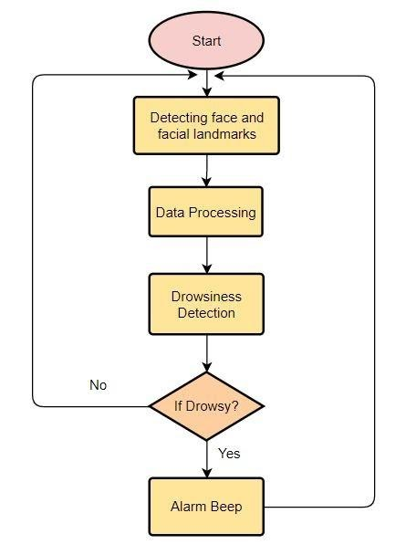

**Chart 1:** Flow of the implementation process

* 1. **Proposed System**

The proposed system suggests a method of detecting driver’s fatigue by analyzing the eye movement of the driver and processing the data collected by the camera. The main purpose of this project is to develop a model of Drowsiness System.

This can be implemented by analysing changes in eye activity and facial expressions of the driver and which henceforth will alert the driver and the people present in the car about the situation and which will further help in processing the current status and take necessary measures.

We have used 2 Methods to track the eye movements of the driver.

* + 1. **Eye Aspect Ratio (EAR)**

This method makes use of the facial edges. This will help us to understand the presence of landmarks on the facial structure of the driver. This data will be further processed and the program will plot the points on region of interests in other such areas if they exist.

This program predominantly uses the Haar Cascade image classifier which will be responsible for estimation of probable distance between keys points we used. This will lead to the generation of program that can determine if the driver’s eyes are closed if the Eye Aspect ratio falls below a certain threshold point.

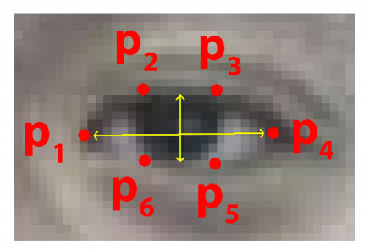

**Fig -1**: Representation of an eye with 6 coordinates

As shown in the figure we get to see that each eye is represented by 6 coordinates p1, p2, p3, p4, p5 lastly p6 starting from the left-hand side and then plotting in clockwise direction around the unmarked region.

Based on the reference work by Soukupová and Čech in their 2016 paper, Real-Time Eye Blink Detection using Facial Landmarks, we can then derive an equation called the Eye aspect ratio (EAR).

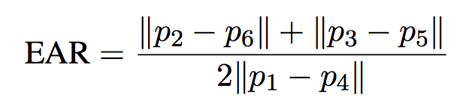

The numerator in this equation will compute the distance between the vertical eye landmarks, and vice versa the denominator computes the distance between horizontal eye landmarks.

The eye aspect ratio is always constant while the eye is open, but will fall to zero when close eyes are detected.

Let us consider the figure from Soukupová and Čech [1]:

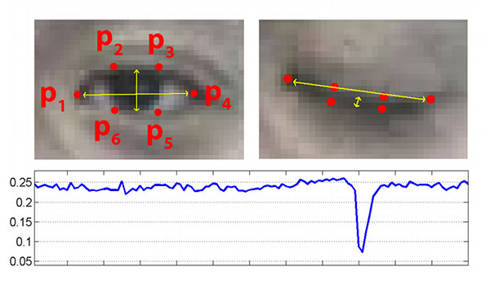

**Fig -2**:  Visualization of eye landmarks when then the eye is open or closed

As we can see in the figure 2 on the left side there is an image of a completely open eye hence the eye aspect ratio is high and relatively constant. And on the other half we can see that when close eye is detected the eye aspect ratio will drastically go downhill approaching almost zero in no time. If the eye aspect ratio is low for a particular number of frames, then the alarm will beep.

* + 1. **CNN MODEL**

Let us consider the figure 5 given by Sumit Saha [11] in A Comprehensive Guide to Convolutional Neural Networks.

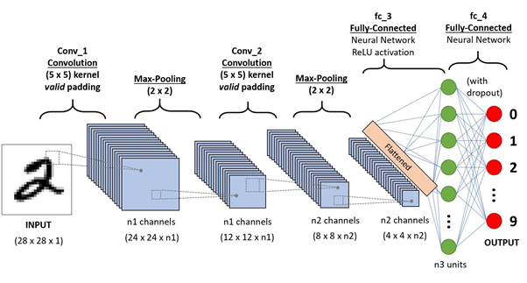

**Fig -3**: A CNN sequence to classify handwritten digits

There are a couple of ways this can be achieved. However, our one such approach is by building a CNN model which will capture the real time images of the driver’s eyes and classify whether the driver is drowsy or not. In order to achieve this goal, we first have to detect the face of the driver. To detect the face, we have used the Haar Cascade dataset from the OpenCV library. This dataset contains XML files of facial images. With the help of this dataset, we were able to extract the face of the driver. After extracting the face, we also need to extract the eyes of that driver. The reason we extract the eyes is because we are developing a CNN model to classify those images. In order to train that model, we have used the eyes dataset from kaggle.com.

This dataset contains approx. 5000 to 7000 images of closed and open eyes. This is what we will train our CNN model on.Now let's dive into the details of our model. To build our CNN model we have used Keras sequential model. So, when the new data instance i.e., the eye image from the driver is fed to the classifier we first pre-process it by scaling it and normalising it. We also convert the image to grayscale in order to reduce the pixel size and complexity as we do not need coloured images. So, after this image is captured, we have augmented it. Data augmentation is one of the highly used techniques to help the model to see through images by zooming in/out, flipping it etc so that our model will generalise properly.

The layers of the model will activate according to the hyperparameters. In order to avoid overfitting, we have added a dropout layer. This will help our model to avoid overfitting. So, after the captured image has passed through all the layers, based on the output of the last layer, if the image is classified as closed then that means the driver might be drowsy.

Now we won’t just yet beep the alarm. If this happens again and again or if the eyes of the driver are found to be closed for a particular number of frames continuously, then we can surely say that the driver is drowsy and accordingly beep the alarm. This is how the basic working of the model-based approach.

As you can see, we first trained our model on 20 epochs. The output of that is mentioned below in chart 2.

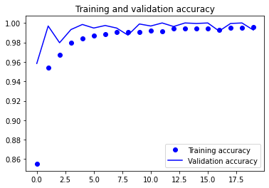

**Chart -2**: Accuracy achieved with 20 epochs

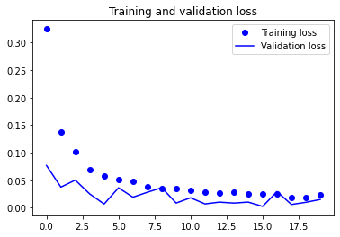

**Chart -3**: Loss occurred with 20 epochs

So, as you can see from the above charts, our model’s accuracy is good, however it looks a little unstable. In order to train our model more accurately and make it more stable, we tried to reduce the number of epochs so that our accuracy and loss curve is smoother and more stable. In order to achieve this, we reduced the number of epochs from 20 to 15 and got a better output.

The graphs in Chart 4 shows the training and validation accuracy with the model trained with 15 epochs.

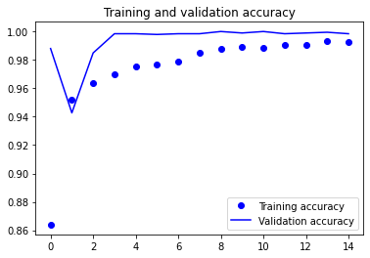

**Chart -4**: Accuracy achieved with 15 epochs

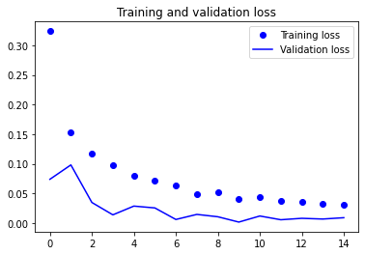

**Chart -5**: Loss occurred with 15 epochs

* 1. **Algorithms**
     1. **HAAR CASCADE CLASSIFIER**

Haar Cascade is a machine learning object detection algorithm used to identify objects in an image or video and based on the concept of **​​** features proposed by Paul Viola and Michael Jones in their paper "Rapid Object Detection using a Boosted Cascade of Simple Features" in 2001.

It is a machine learning based approach where a cascade function is trained from a lot of positive and negative images.It is then used to detect objects in other images.

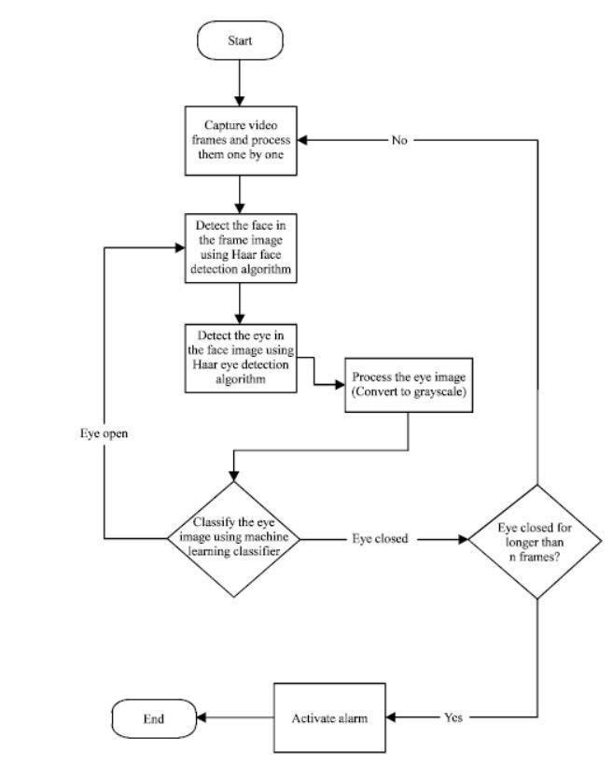

**Fig 4:** Haar Cascade Algorithm

* + 1. **Convolutional Neural Network**

A Convolutional Neural Network (ConvNet/CNN) is a Deep Learning algorithm which can take in an input image, assign importance (learnable weights and biases) to various aspects/objects in the image and be able to differentiate one from the other. The pre-processing required in a ConvNet is much lower as compared to other classification algorithms. While in primitive methods filters are hand-engineered, with enough training, ConvNets have the ability to learn these characteristics.

**A CNN**

1. Starts with an input image.
2. Applies many different filters to it to create a feature map.
3. Applies a relu function to increase non-linearity.
4. Applies a pooling layer to each feature map.
5. Flattens the pooled images into one long vector.
6. Inputs the vector into a fully connected artificial neural network.
7. Processes the features through the network. The final fully connected layer provides the “voting” of the classes that we’re after.
8. Trains through forward propagation and backpropagation for many, many epochs. This repeat until we have a well-defined neural network with trained weights and feature detectors.

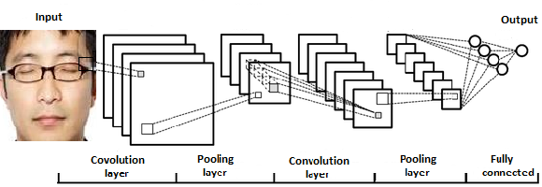

**Fig 5**: Process of CNN

**Chapter 3**

**SYSTEM REQUIREMENTS**

* 1. **Hardware Specification**

* Operating System – Windows 7,8, 10 or Professional editions
* Processor - dual core 2.4 GHz+ (i5 or i7 series Intel processor or equivalent AMD)
* RAM – 4 GB
* Hard Drive - 256 GB or larger solid-state hard drive

* 1. **Software Specification**

* Python 2.7.15 +
* PIP 2.7
* Pycharm
* Jupyter Notebook

**Chapter 4**

**PROJECT IMPLEMENTATION**

* 1. **Use Case Diagram**

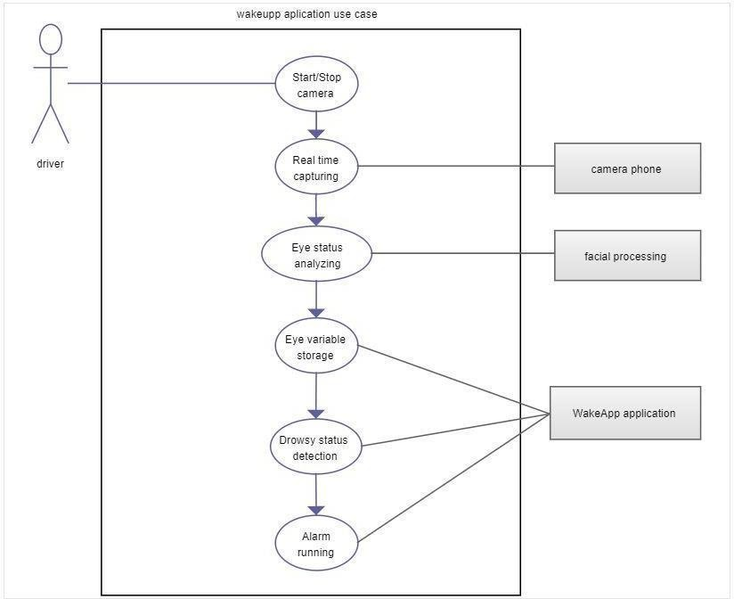

**Fig 6:** Use Case Diagram of the proposed system

* 1. **Data Flow Diagram**

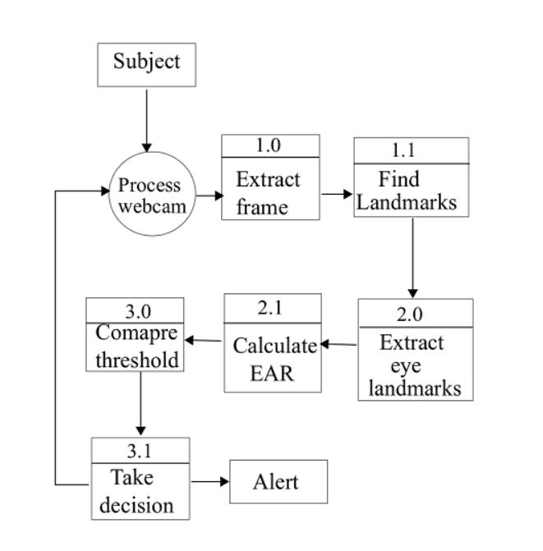

**Fig 7:** Data Flow Diagram of the Proposed System

* 1. **Eye Aspect Ratio Code**

import argparse  
import imutils  
import time  
import dlib  
import cv2

from pygame import mixer  
from scipy.spatial import distance as dist  
from imutils.video import VideoStream  
from imutils import face_utils  
  
mixer.init()  
sound = mixer.Sound('alarm.wav')  
  
def EAR_METHOD(eye):  
 A = dist.euclidean(eye[1], eye[5])  
 B = dist.euclidean(eye[2], eye[4])  
 C = dist.euclidean(eye[0], eye[3])  
 ear = (A + B) / (2.0 * C)  
 return ear  
  
def EAR_RESULT(shape):  
 (left_begin, left_end) = face_utils.FACIAL_LANDMARKS_IDXS["left_eye"]  
 (right_begin, right_end) = face_utils.FACIAL_LANDMARKS_IDXS["right_eye"]  
 Scan_left_Eye = shape[left_begin:left_end]  
 Scan_right_Eye = shape[right_begin:right_end]  
 leftEAR = EAR_METHOD(Scan_left_Eye)  
 rightEAR = EAR_METHOD(Scan_right_Eye)  
 ear = (leftEAR + rightEAR) / 2.0  
 return (ear, Scan_left_Eye, Scan_right_Eye)  
  
  
ap = argparse.ArgumentParser()  
ap.add_argument("-w", "--webcam", type=int, default=0,  
 help="index of webcam on system")  
args = vars(ap.parse_args())

EYE_AR_THRESH = 0.3  
EYE_AR_CONSEC_FRAMES = 30  
COUNTER = 0  
  
detector = cv2.CascadeClassifier("haarcascade_frontalface_default.xml")  
predictor = dlib.shape_predictor('shape_predictor_68_face_landmarks.dat')  
  
print("-> Starting Video Stream")  
  
vs = VideoStream(src=args["webcam"]).start()  
time.sleep(1.0)  
  
while True:  
 frame = vs.read()  
 if vs==False:  
 print('Could not Capture image from camera')  
 break  
  
 frame = imutils.resize(frame, width=450)  
 gray = cv2.cvtColor(frame, cv2.COLOR_BGR2GRAY)  
  
 rectshapes = detector.detectMultiScale(gray, scaleFactor=1.1,  
 minNeighbors=5, minSize=(30, 30),  
 flags=cv2.CASCADE_SCALE_IMAGE)  
  
  
 for (x, y, w, h) in rectshapes:  
 rectshape = dlib.rectangle(int(x), int(y), int(x + w), int(y + h))  
  
  
 shape = predictor(gray, rectshape)  
 shape = face_utils.shape_to_np(shape)  
  
 eye = EAR_RESULT(shape)  
 ear = eye[0]  
 Scan_left_Eye = eye[1]  
 Scan_right_Eye = eye[2]  
  
  
 leftEyeHull = cv2.convexHull(Scan_left_Eye)  
 rightEyeHull = cv2.convexHull(Scan_right_Eye)  
 cv2.drawContours(frame, [leftEyeHull], -1, (0, 255, 0), 1)  
 cv2.drawContours(frame, [rightEyeHull], -1, (0, 255, 0), 1)  
  
  
 if ear < EYE_AR_THRESH:  
 COUNTER += 1  
  
 if COUNTER >= EYE_AR_CONSEC_FRAMES:  
 try:  
 sound.play()  
 print("Warning! Driver is sleepy please wake up ")  
  
 except:  
 pass  
  
 cv2.putText(frame, "Driver Drowsiness Alert!", (10, 30),  
 cv2.FONT_HERSHEY_SIMPLEX, 0.7, (0, 0, 255), 2)  
  
 else:  
 COUNTER = 0  
  
 cv2.putText(frame, "EAR: {:.2f}".format(ear), (300, 30),  
 cv2.FONT_HERSHEY_SIMPLEX, 0.7, (0, 0, 255), 2)  
  
 cv2.imshow("Frame", frame)  
 key1 = cv2.waitKey(1) & 0xFF  
  
 if key1 == ord("q"):  
 break  
  
cv2.destroyAllWindows()  
vs.stop()

* 1. **CNN MODEL CODE**

import random,shutil

from keras.models import Sequential

from keras.layers import Dropout,Conv2D,Flatten,Dense, MaxPooling2D, BatchNormalization

from keras.models import load_model

import os

from keras.preprocessing import image

import matplotlib.pyplot as plt

import numpy as np

from keras.utils.np_utils import to_categorical

generator=image.ImageDataGenerator(rescale=1./255,horizontal_flip=True)  
class_mode='categorical'  
  
train=generator.flow_from_directory('C:\\Users\\Vedant\\Desktop\\eye_dataset_splitted\\train',shuffle=True,color_mode='grayscale',class_mode=class_mode, batch_size=32,target_size=(24,24))  
valid=generator.flow_from_directory('C:\\Users\\Vedant\\Desktop\\eye_dataset_splitted\\valid',shuffle=True, batch_size=32,target_size=(24,24),color_mode='grayscale',class_mode=class_mode)  
  
SPE= len(train.classes)//32  
VS = len(valid.classes)//32  
print(SPE,VS)  
  
# img,labels= next(train_batch)  
# print(img.shape)  
model=Sequential()

model.add(Conv2D(32, kernel_size=(3, 3), activation='relu', input_shape=(24,24,1)))  
model.add(MaxPooling2D(pool_size=(1,1)))  
#model.add(Conv2D(64,(3,3),activation='relu'))  
#model.add(MaxPooling2D(pool_size=(1,1)))  
model.add(Dropout(0.25))  
#model.add(Conv2D(128, (3, 3), activation='relu'))  
#model.add(Dropout(0.25))  
#model.add(BatchNormalization())  
#model.add(MaxPooling2D(pool_size=(1,1)))  
#model.add(Dropout(0.5))  
model.add(Flatten())  
  
model.add(Dense(64, activation='relu'))  
model.add(Dropout(0.5))  
model.add(Dense(2, activation='sigmoid'))  
  
  
model.compile(optimizer='adam',loss='categorical_crossentropy',metrics=['accuracy'])  
#print(1)  
hist= model.fit(train, validation_data=valid,epochs=15,steps_per_epoch=SPE ,validation_steps=VS)  
model.summary()

**Output for the epochs:**

Found 5000 images belonging to 2 classes.

Found 1950 images belonging to 2 classes.

156 60

Epoch 1/15

156/156 [==============================] - 21s 128ms/step - loss: 0.5861 - accuracy: 0.6896 - val_loss: 0.1218 - val_accuracy: 0.9479

Epoch 2/15

156/156 [==============================] - 11s 68ms/step - loss: 0.2668 - accuracy: 0.8776 - val_loss: 0.0678 - val_accuracy: 0.9703

Epoch 3/15

156/156 [==============================] - 11s 67ms/step - loss: 0.1963 - accuracy: 0.9231 - val_loss: 0.0937 - val_accuracy: 0.9505

Epoch 4/15

156/156 [==============================] - 11s 68ms/step - loss: 0.1591 - accuracy: 0.9320 - val_loss: 0.0363 - val_accuracy: 0.9833

Epoch 5/15

156/156 [==============================] - 11s 68ms/step - loss: 0.1324 - accuracy: 0.9357 - val_loss: 0.0244 - val_accuracy: 0.9969

Epoch 6/15

156/156 [==============================] - 11s 69ms/step - loss: 0.1222 - accuracy: 0.9369 - val_loss: 0.0507 - val_accuracy: 0.9854

Epoch 7/15

156/156 [==============================] - 11s 70ms/step - loss: 0.1144 - accuracy: 0.9555 - val_loss: 0.0131 - val_accuracy: 0.9974

Epoch 8/15

156/156 [==============================] - 11s 67ms/step - loss: 0.0895 - accuracy: 0.9594 - val_loss: 0.0099 - val_accuracy: 0.9984

Epoch 9/15

156/156 [==============================] - 11s 68ms/step - loss: 0.0756 - accuracy: 0.9638 - val_loss: 0.0203 - val_accuracy: 0.9984

Epoch 10/15

156/156 [==============================] - 11s 68ms/step - loss: 0.0692 - accuracy: 0.9758 - val_loss: 0.0184 - val_accuracy: 0.9990

Epoch 11/15

156/156 [==============================] - 11s 68ms/step - loss: 0.0667 - accuracy: 0.9790 - val_loss: 0.0109 - val_accuracy: 0.9990

Epoch 12/15

156/156 [==============================] - 11s 69ms/step - loss: 0.0606 - accuracy: 0.9774 - val_loss: 0.0164 - val_accuracy: 0.9964

Epoch 13/15

156/156 [==============================] - 11s 68ms/step - loss: 0.0564 - accuracy: 0.9815 - val_loss: 0.0245 - val_accuracy: 0.9969

Epoch 14/15

156/156 [==============================] - 11s 68ms/step - loss: 0.0587 - accuracy: 0.9778 - val_loss: 0.0203 - val_accuracy: 0.9958

Epoch 15/15

156/156 [==============================] - 11s 70ms/step - loss: 0.0512 - accuracy: 0.9822 - val_loss: 0.0033 - val_accuracy: 1.0000

Model: "sequential"

_________________________________________________________________

Layer (type) Output Shape Param #

=================================================================

conv2d (Conv2D) (None, 22, 22, 32) 320

_________________________________________________________________

max_pooling2d (MaxPooling2D) (None, 22, 22, 32) 0

_________________________________________________________________

dropout (Dropout) (None, 22, 22, 32) 0

_________________________________________________________________

flatten (Flatten) (None, 15488) 0

_________________________________________________________________

dense (Dense) (None, 64) 991296

_________________________________________________________________

dropout_1 (Dropout) (None, 64) 0

_________________________________________________________________

dense_1 (Dense) (None, 2) 130

=================================================================

Total params: 991,746

Trainable params: 991,746

Non-trainable params: 0

**Chapter 5**

**RESULT**

**5.1. OUTPUT OF EAR**

The result of the EAR can be seen in the figure 3 and 4 given below:

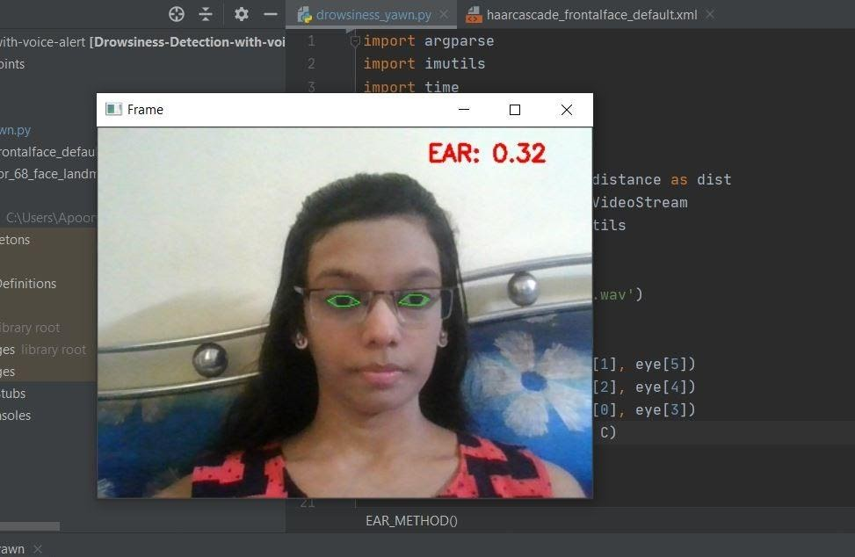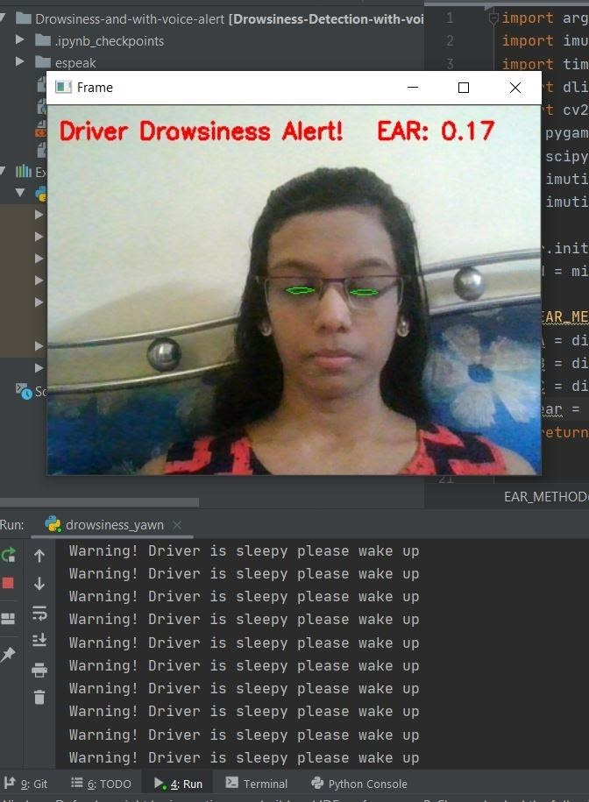

**Fig 8**: Result of EAR when eyes are open **Fig 9**: Result of EAR when eyes are closed

We can see that near the region of interest which in our case are the eyes a presence of green outline which is the landmark detected by the Eye aspect ratio. Eye aspect ratio assists us to plot coordinates by identifying the facial landmarks.

While we can see that in the figure 4 the person has their eyes closed due to which the value of Eye aspect ratio continues to drop as compared to the value when the person has their eyes open. When the Eye aspect ratio falls under a certain threshold limit an alert is triggered which will cause the alarm to beep and alert the driver.

**5.2. OUTPUT OF CNN:**

The output of our model is shown below:

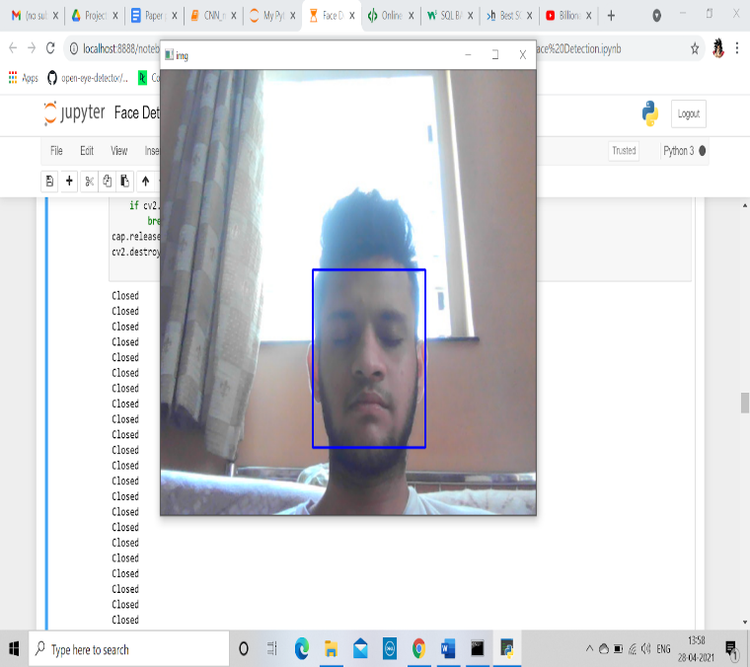

**Fig 10**: Result of CNN model when eyes are closed

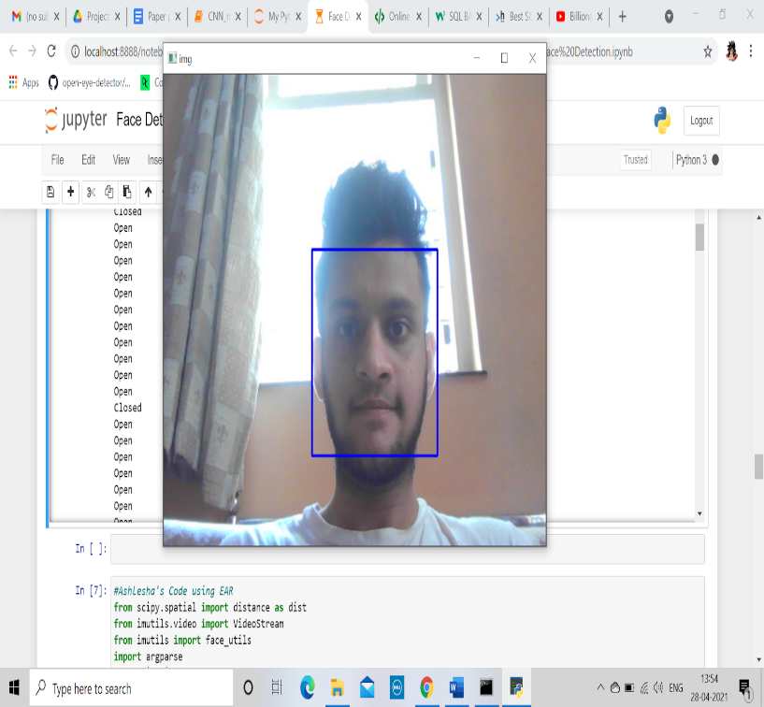

**Fig 11**: Result of CNN model when eyes are open

**Chapter 6**

**6.1. Conclusion**

The drowsiness plays a pivotal role in ensuring safe driving environment. This paper proposed a drowsiness detection system solely based on camera monitoring. The function of this project is to detect the facial landmarks of the driver and provide the obtained result from the trained model or EAR method to judge the driver’s state whether the driver is attentive or not and throw alert by beeping an alarm to warn the driver accordingly. As of now this project is implemented on a small scale. With some enhancements this project can be used by the general public. Making the maximum use of its cost-efficient nature multiple drowsiness related accidents can be avoided. Henceforth we can conclude that this project will help to detect the indication of driver’s distracted driving which may help us to avoid serious aftermaths at an early level where drowsiness is just emerging.

The study will show promising results in applying the vehicular driver surveillance based on vision techniques and implemented in a smartphone. The implemented system allows an efficient detection of the indicators that appear in drowsiness, as long as the measurements are carried out under the established conditions. The correct functioning of the system depends on these conditions.

The increase in the processing characteristics in smartphones made it possible to develop an application of vision, capable of detecting the face and visual indicators present in a person who suffers from the state of the eyes.

The greater intensity of drowsiness means a higher loss of concentration and a lower ability of driver reaction. In development of this work, the implementation of 3 levels of sleepiness allows the system to alert the driver about their condition, not necessarily at a critical level where it may have serious aftermaths, rather at early levels where drowsiness is just emerging.

**6.2. Future Scope**

Further in future we can improve the quality of this drowsiness detection system project. As of now we are able to monitor the driver’s eye movements in order to get the result. It can further be improved by analyzing the movements made by the steering wheel or monitor if the driver makes any sudden drifts out of nowhere, we can warn the driver accordingly. As yawning is also a trait of an incoming sleep, we would also further work on yawning analysis by collecting the landmarks of the mouth.

This project can also be used by Driver management companies like Uber or Ola who provide their services even during the night time which is the peak time where drowsiness is prominently seen. In order to cope up with this issue we can store the data of the driver and if the driver tends to get multiple warnings it can alert the driving agency and change the shift of the driver in the time where the driver is fully attentive.

**REFERENCES**

[1] Tereza Soukupova and Jan ´ Cech ˇ. “Real-time eye blink detection using facial landmarks”, 21st Computer Vision Winter Workshop,Corpus ID:21124316.

[2] B. Bhowmick and K. Chidanand Kumar. “Detection and classification of eye state in IR camera for driver drowsiness identification”. In IEEE ICSIPA ’09, Pages 340–345, 2009.

[3] Federico Guede-fernández. “Driver Drowsiness Detection Based on Respiratory Signal Analysis”, In IEEE Access, pages 81826-81838.

[4] [Md. Yousuf Hossain](https://www.computer.org/csdl/search/default?type=author&givenName=Md.%20Yousuf&surname=Hossain), IOT based real-time drowsy driving detection system for the prevention of road accidents, ICIIBMS 2018, Pages: 190-195.

[5] A. Subbarao, Driver Drowsiness Detection System for Vehicle.Safety,(IJITEE).Pages:815-819<https://www.ijitee.org/wp-content/uploads/papers/v8i6s4/F11640486S419.pdf>

[6]..Sanya Gupta, Drowsy driver alerting system-Proceedings of the 2nd International conference on Electronics, Communication and Aerospace Technology (ICECA 2018) IEEE Conference Record Pages:1665-1670

[7] A Survey on Drowsy Driver Detection System -2017 International Conference on Big Data Analytics and computational Intelligence (ICBDACI) Pages:272-279

[8] Drowsy Driving NHTSA reports. (2018, January 08). Retrieved.from..<https://www.nhtsa.gov/risky-driving/drowsy-driving>.

[9] World Health Organization The top ten causes of death.   <https://www.who.int/news-room/fact-sheets/detail/the-top-10-causes-of-death>

[10].Damian.Salapatek,.Driver.Drowsiness.Detection.System<https://www.researchgate.net/publication/319464008> Pages:41-47

[11] Sumit Saha, A Comprehensive Guide to Convolutional Neural Networks - the ELI5 way.

<https://towardsdatascience.com/a-comprehensive-guide-to-convolutional-neural-networks-the-eli5-way-3bd2b1164a53>

[12] Kavyan Shah, Eye-Dataset, Eyes seeing in that direction

<https://www.kaggle.com/kayvanshah/eye-dataset>

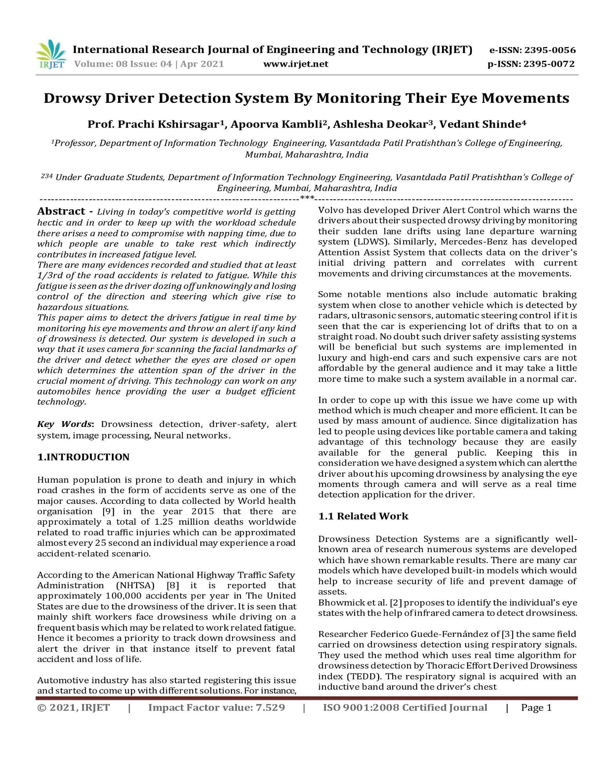**PUBLICATION**

